Creating AWS Streaming Configuration.

**Pre-conditions:** You need to create a policy with below permission, and attach this policy to the c3m-user-assume-role (user created during account onboarding), this is essential for streaming events.

Go to <https://console.aws.amazon.com/iam/>

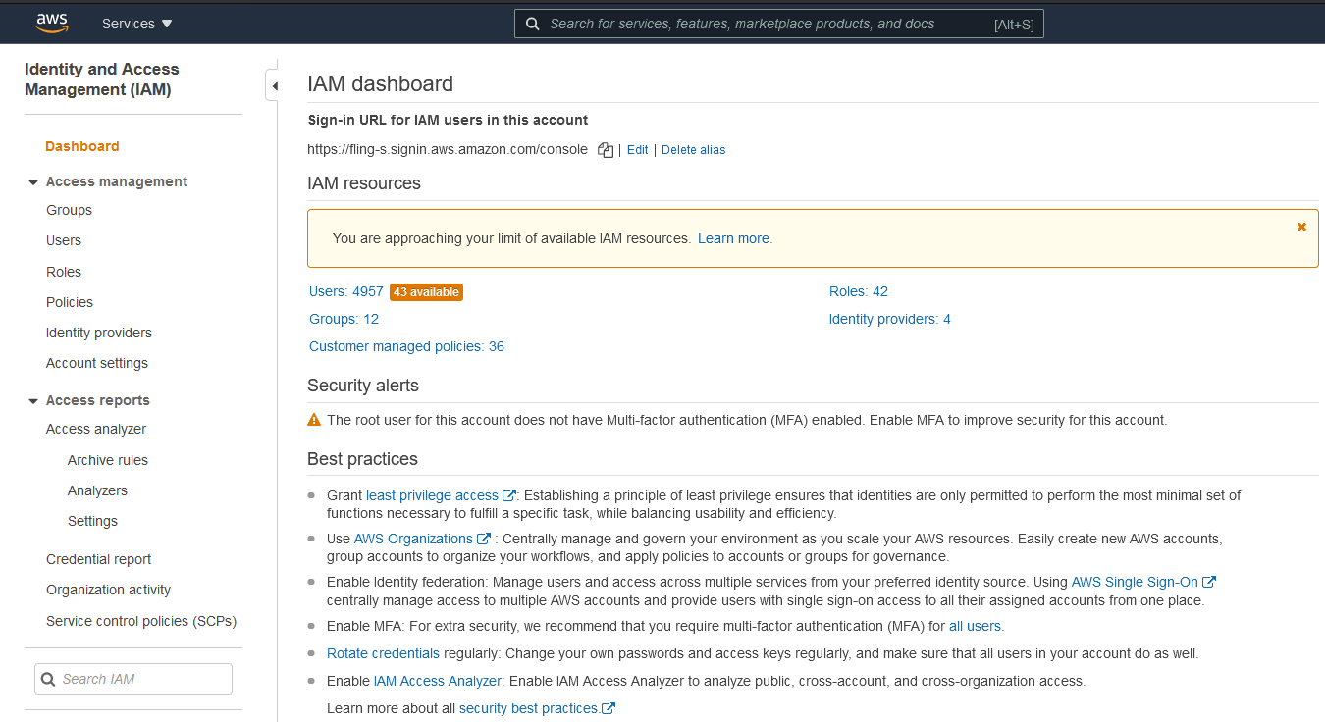

Click on Roles on the right hand of the page, **IAM Roles** listing page is loaded

Choose the user (created while onboarding the account) from the list and click on it, **Summary** page is loaded.

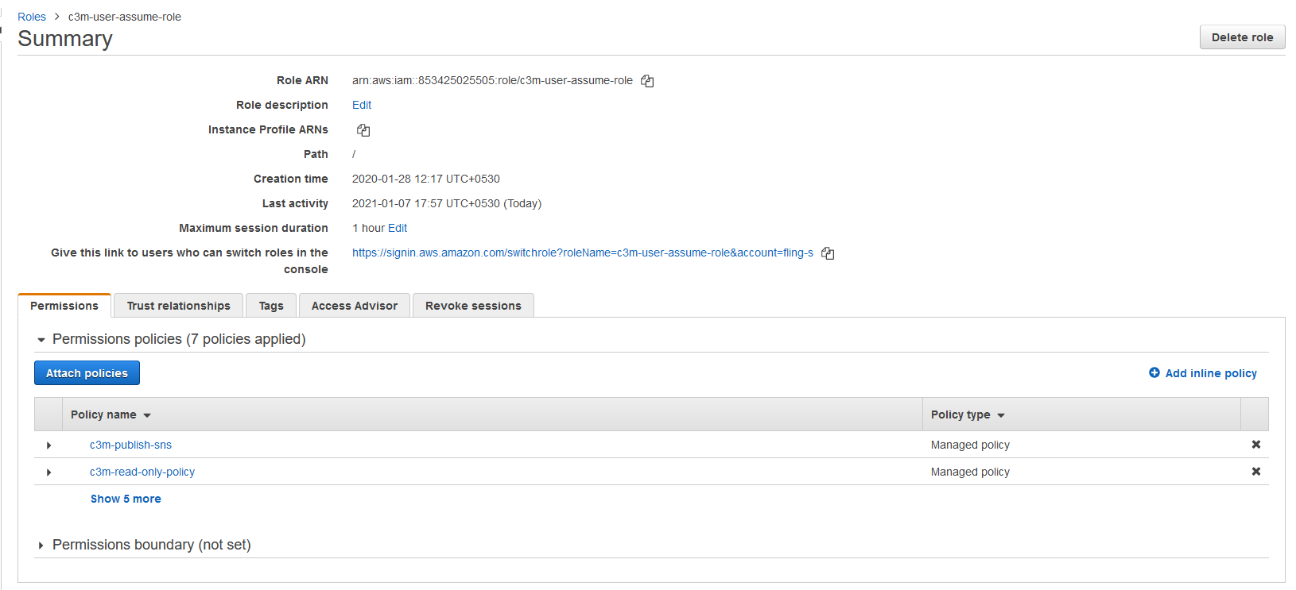

Click on **Add inline policy,** **Create Policy** page is loaded.

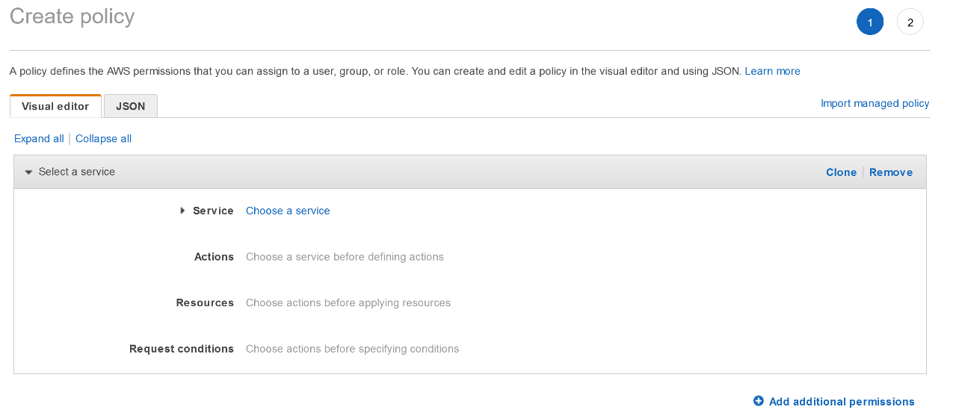

Click on **JSON** tab and paste the following snippet.



After pasting the contents, click on **Review Policy** button at the bottom of the page.



AWS will consume about 10 seconds and then **Review Policy** page is loaded.

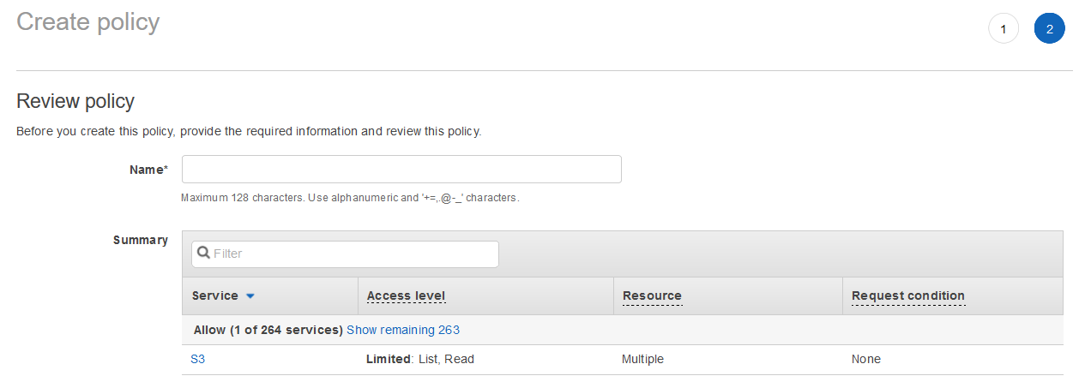

Enter a **Name** to the policy, and click on **Create policy** button at the bottom of the page.

Once the policy is created, the **Summary** page is loaded

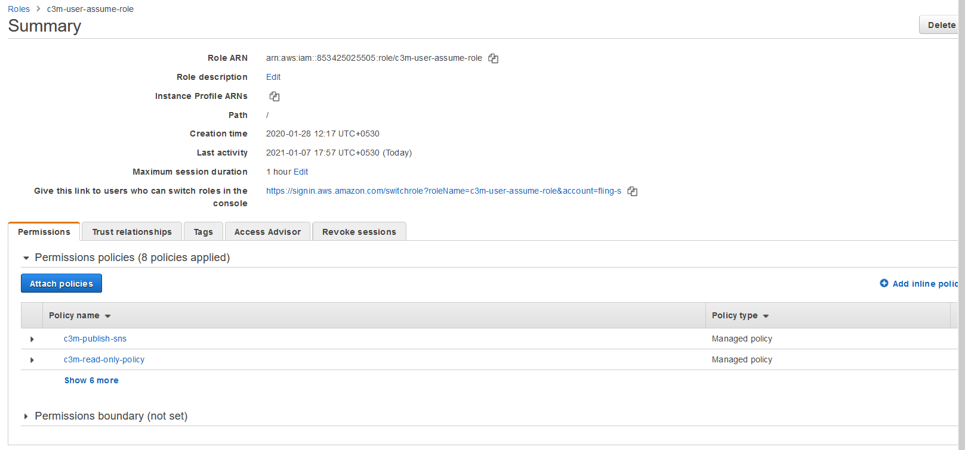

Create Simple Notification Service Topic in AWS Console in an account.

* Go to AWS portal

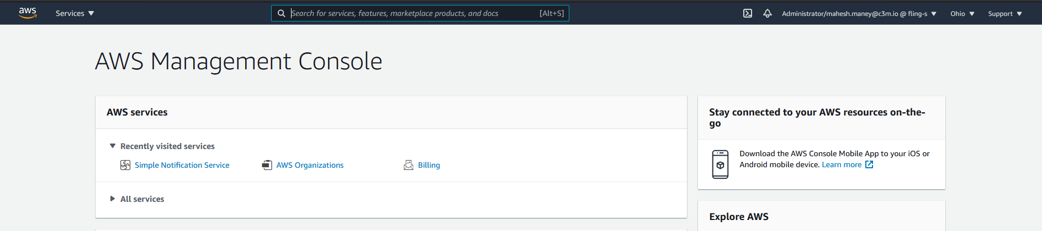

* On the top left of the screen, click on **Service** and navigate to **Simple Notification Service** (on the right-hand side of the screen) and click on it.

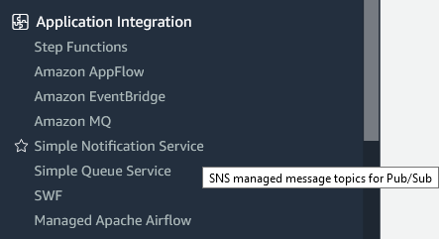

Amazon SNS Dashboard page is loaded.

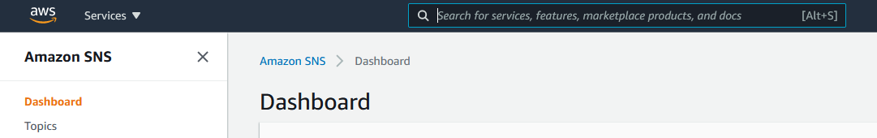

* Choose **Topics** and to click on **Create Topic** button.

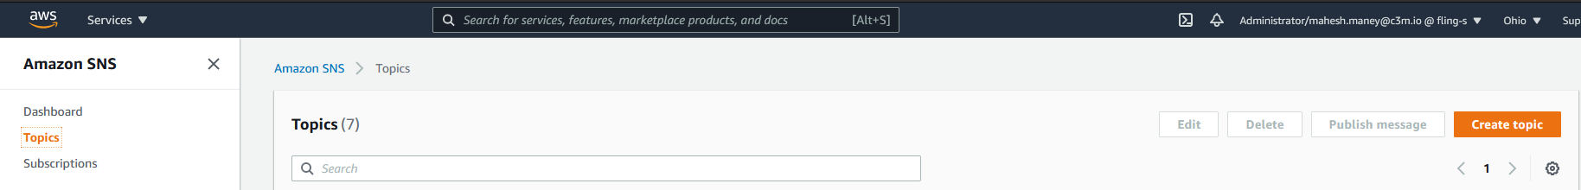

The **Create Topic** page is loaded.

* Under **Type Info**, choose **Standard**
* Enter a name Topic-Name
* Enter a display-name

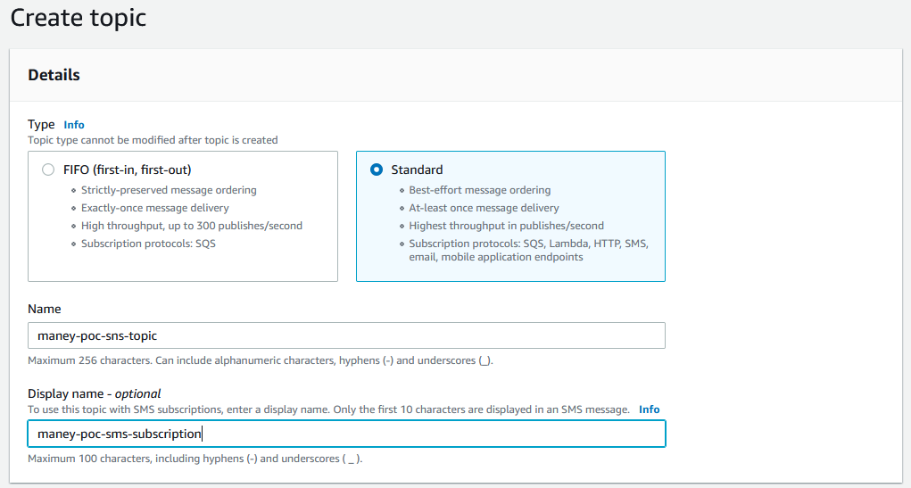

Other entries are optional and we shall ignore other items in the windows

* Click on Create Topic button at the bottom of the screen



Topic Details page is loaded.

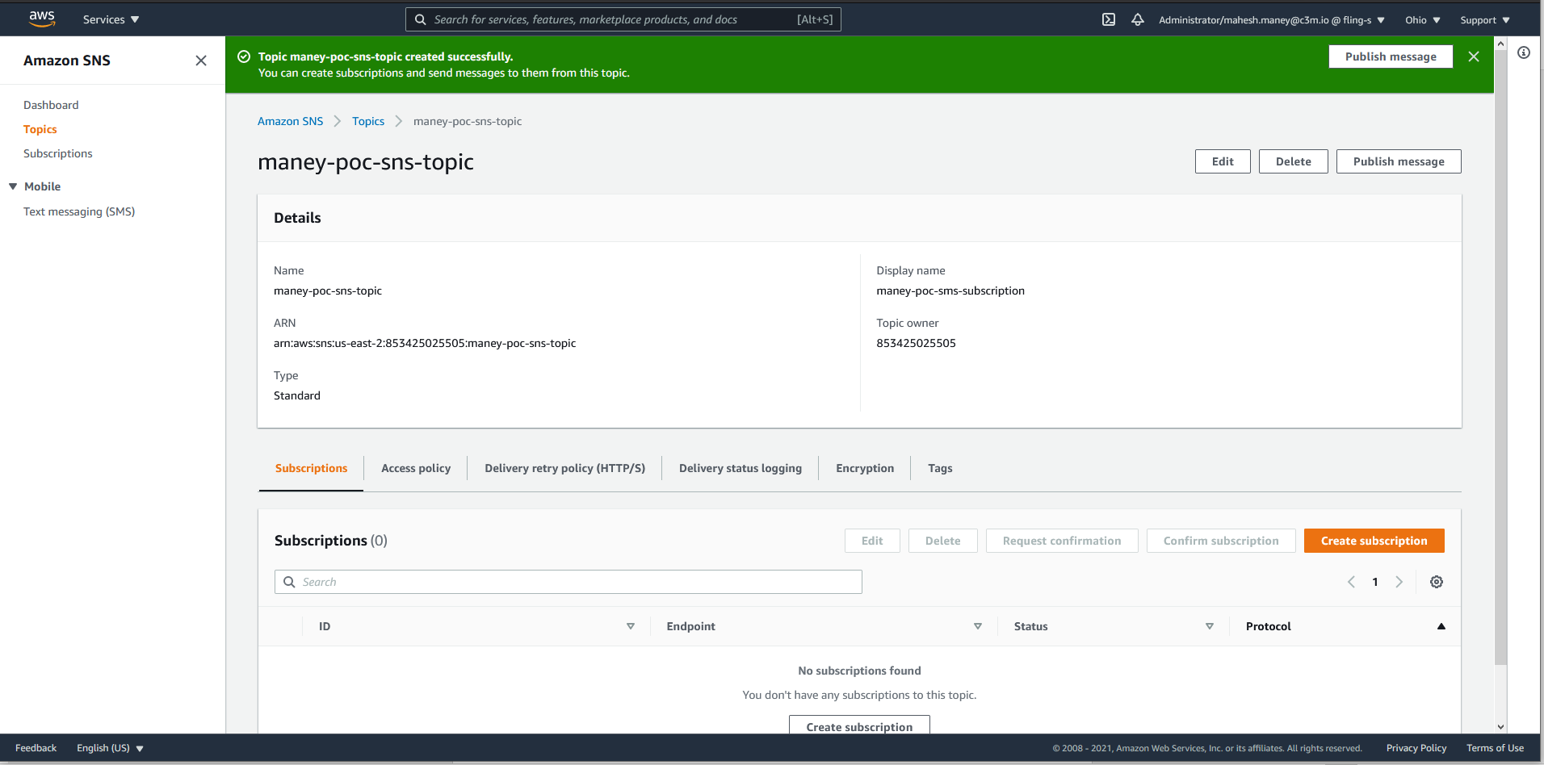

Now, we shall create a cloud trail. Open the CloudTrail console at <https://console.aws.amazon.com/cloudtrail/home/>

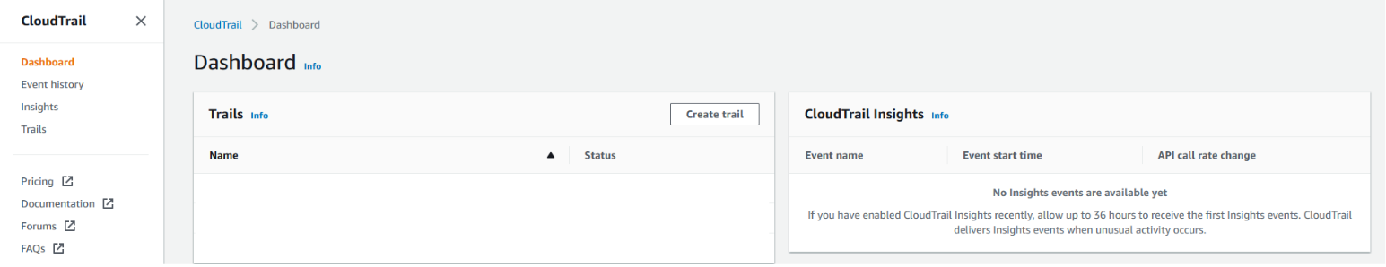

The Cloud Trail dashboard page is loaded.

* Click on the **Create Trail** button, the **Choose Trail Attributes** page is loaded
  + Enter a trail name
  + Choose appropriate storage location
* Choose Create new S3 bucket, if you want to create a new S3 bucket

**Trail log Bucket and Folder** will be auto filled. You may choose to accept it or enter your desired name.

* Choose Use existing S3 bucket, if you have created a S3 bucket earlier and have the configuration details handy with you.

**Trail log Bucket Name** should be filled by clicking on **Browse** button and choosing the appropriate **S3 Bucket** from the list.

* Make sure the **Log file SSE-KMS encryption** checkbox is enabled.
* In the **AWS KMS customer managed CMK** section, choose

**New**: If you want to create a new CMK

**Existing**: Choose from the list.

* Under **Log file validation** section, check the E**nabled** checkbox
* Under **SNS notification delivery**, check the **Enabled** checkbox
* Under **Create a new SNS topic** section, select **Existing** and choose the SNS Topic we had created earlier
* Click on Next button. **Choose Events Log** page is loaded.

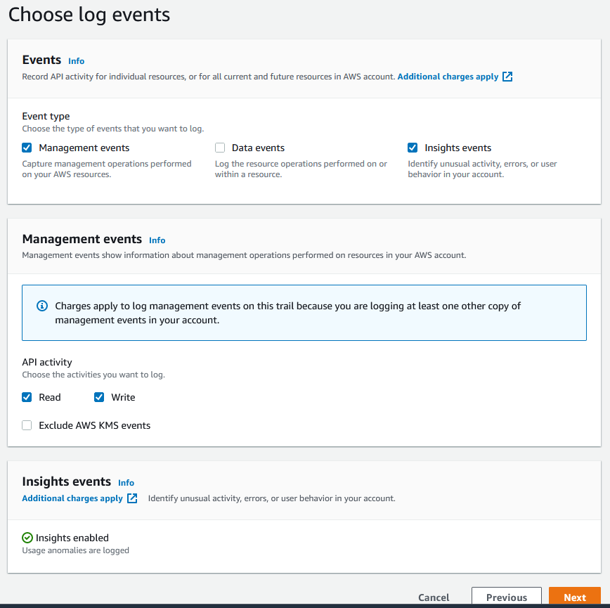

Under Event Type section, select **Management events** and **Data Events** checkbox.

You may choose Data Events, if you want to log the resource operations performed on a resource.

* Click on **Next** button. **Review and Create** page is loaded.
* Carefully review the page details and if you feel the right data is entered, you may click on **Create Trail** button.

It may take about 5 seconds and load the **Trails** listing page. The new created Trail will be listed in here.

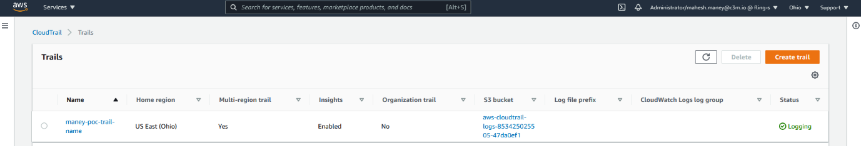

Login to - <https://ccdev.c3m.app>

Navigate to **Administration** –> **Platform Settings**

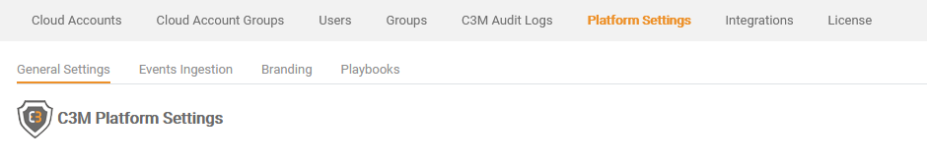

Click on **Events Ingestion**

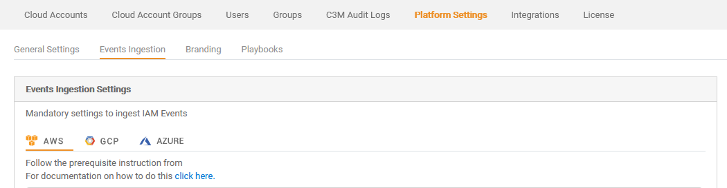

Choose AWS

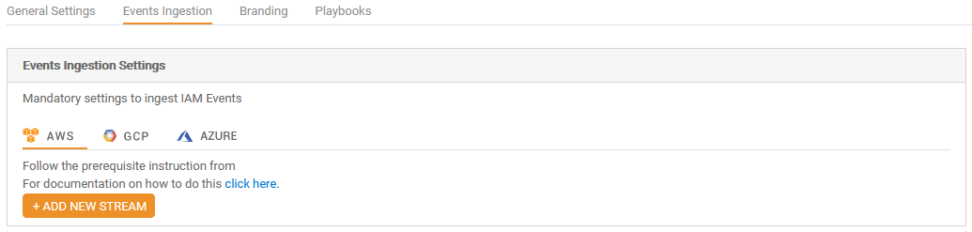

Click on **ADD NEW STREAM** button,

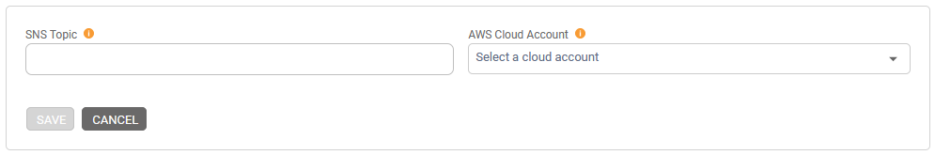

Enter **SNS Topic** that you just created and Choose the **AWS Cloud Account** and click on **Save**.

C3M app will generate a **webhook URL**.

A sample webhook URL will look like - https://ccqamg.c3m.app/SNS/publish/de705724f7efa1213ecba313c489bb9160b88752acb98c86c7c

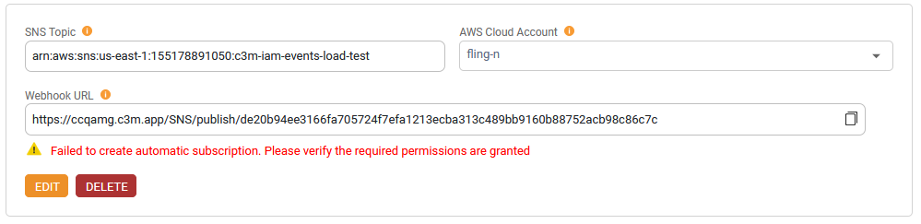

Now, Let’s create a subscription for the topic we just created.

* On the top left side of the screen, click on **Service** dropdown



and choose **Simple Notification Services** (on the left-hand side of the screen)



Amazon SNS Dashboard page is loaded.



* Click on **Topic** and the **Topics** listing page is loaded

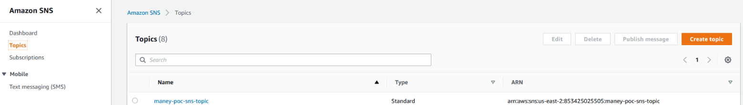

* Click on the topic we just created, and the **Topics detailed** page is loaded.

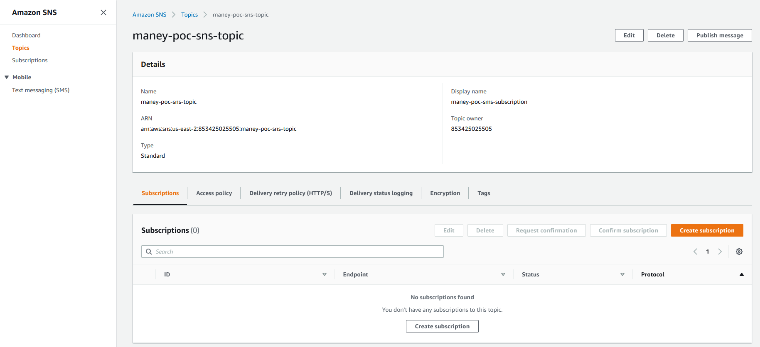

* Click on **Subscription** and the **Create Subscription** page is loaded.
* **Topic ARN** field is auto filled
* Choose **HTTPS** from the **Protocol** dropdown box
* In the **Endpoint** field, paste the URL

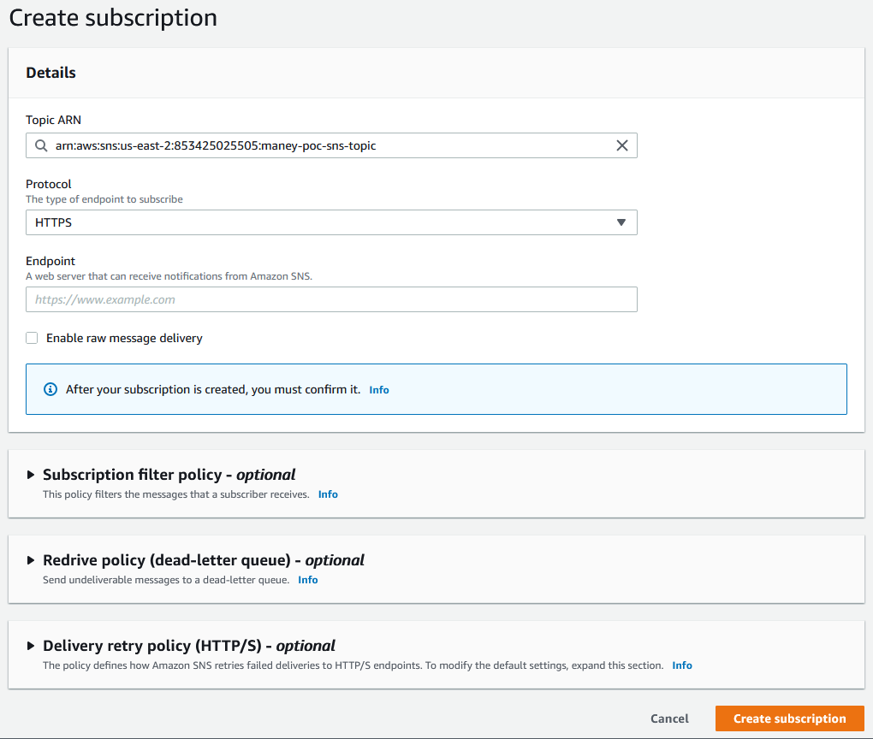

* Click on **Create Subscription** button and the page is loaded.

The subscription that you just created will be in pending status. To view the subscription status, select the topic that you created from the Topic listing page and the topic details page is loaded.

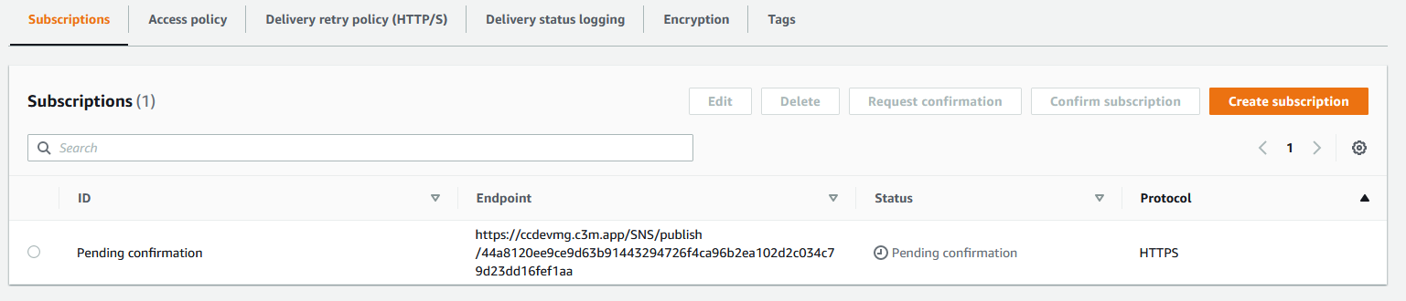

* Click on **Pending Confirmation** radio button and



* click on **Request Confirmation** button



On successful confirmation, you get a notification on top of the screen



[**This section needs review, since we need to fetch the URL and add it to the AWS**]

Go to Kibana and search for “SubscribeURL”

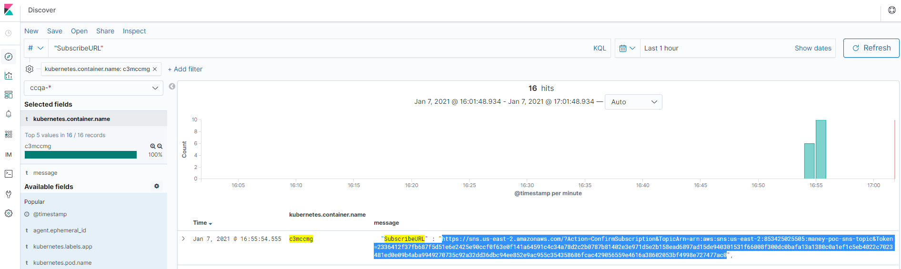

Look for an entry that contains the Topic you just created and copy the URL.

Back to this page,



Click on **Confirm subscription** button, a window pops up

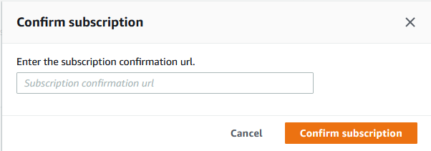

Paste the subscribeUL here and click on **Confirm Subscription** button.